# ***TERRAFORM INSTALLATION***

* Download Terraform from <https://www.terraform.io/downloads.html>
* Select appropriate operating system and version.
* Download the file.
* Unzip the file in your downloaded location.
* Copy the file to an appropriate location as desired.
* Copy the path of the file stored in your computer.
* **Example Screenshot :**
* 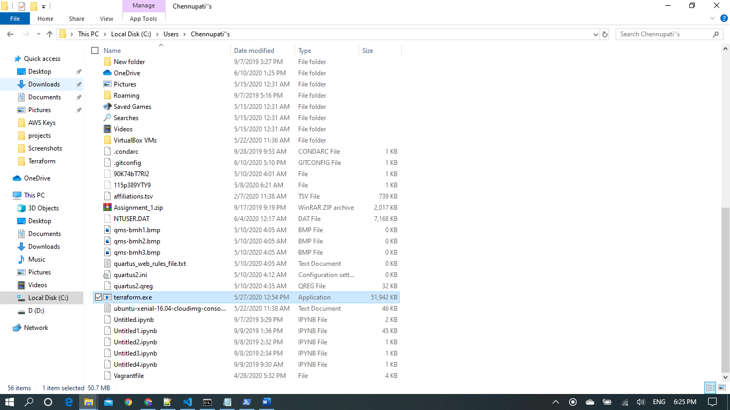
* Now set the path of the environment variable in your machine.
* Go to windows> type in “environment variables” in the search and open the system properties window.
* 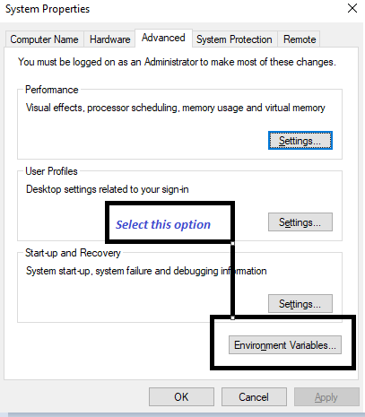
* 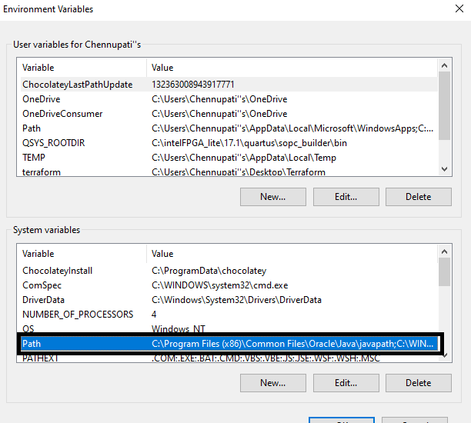
* Select the “Path” under “System Variables” and select “Edit” option.
* 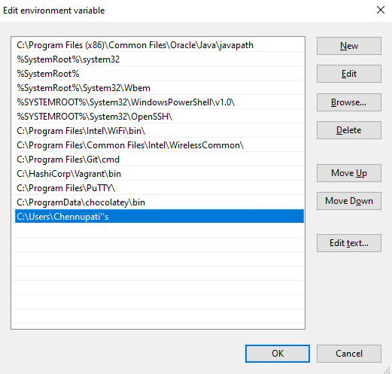
* Select “New” and add your custom terraform path as the environment variable under edit environment variable and click ok
* Terraform in installed. To check the installation open command prompt or windows PowerShell and type the command “terraform -version” to check the version of terraform installed.